**Big Data – 7 Notes**

Closeness Centrality: Average closest path to all other nodes. Best nodes to pass information to all other nodes in the network.

Closeness: Average closest node to all node.

Degree:

Between-ness: Information has to go through this node. Exists between all other nodes. Resilience nodes.

Eigenvalue: “Important”, it’s who you know. A lot of connections.

**Degree Centrality**

More important path is the in-network.

Think about someone who is constantly sending out tweets vs someone who has tweets being directed towards them.

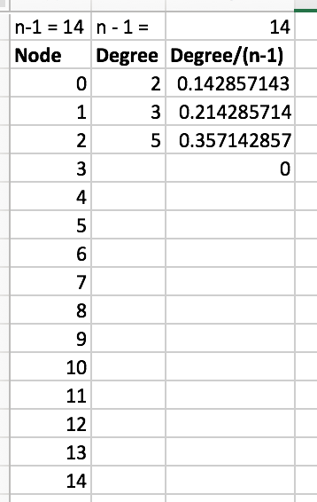

**Closeness Centrality**

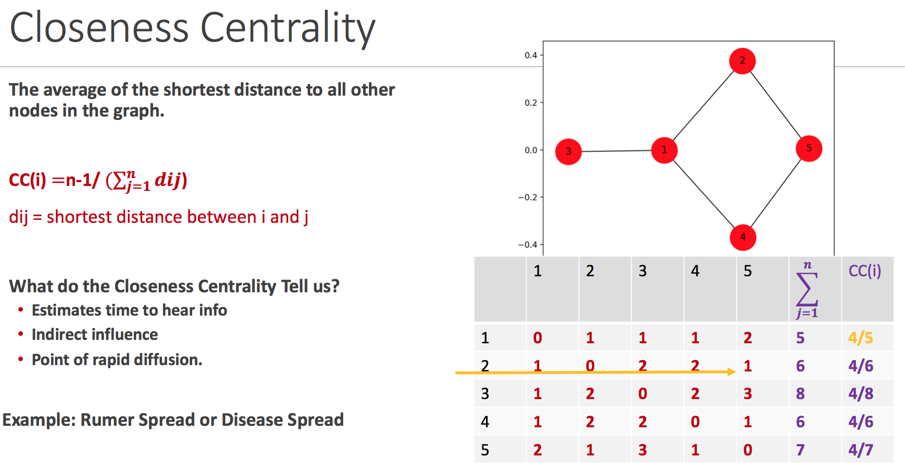

Average shortest path to other nodes.

We want the node that is the closest to all. **The highest average is the winner**. So in this case, node 1 is the winner.

**Between-ness Centrality**

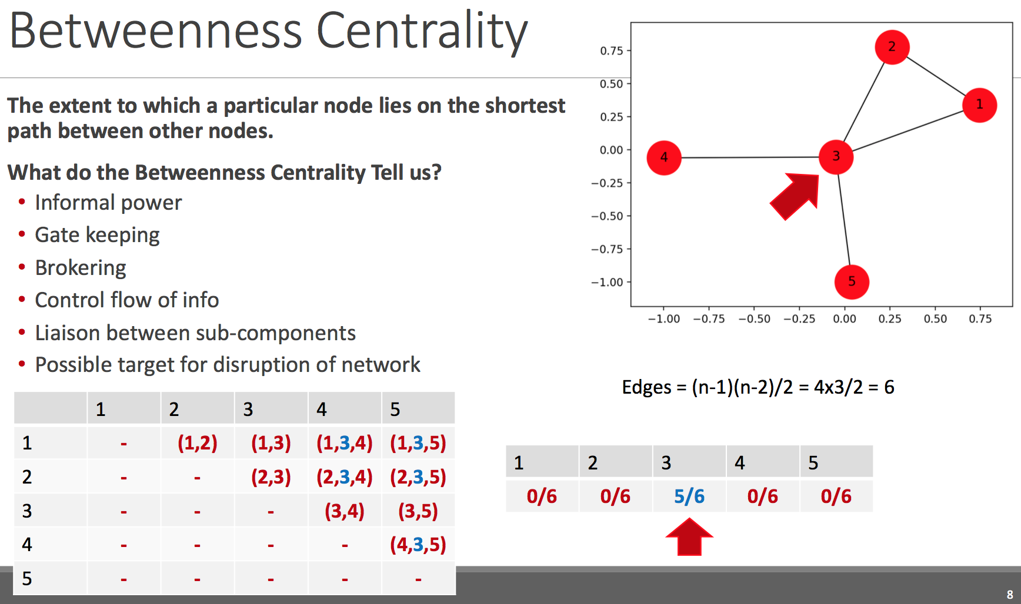

Bridge between all of the others. Very expensive to compute.